Task 3 Description

Introduction
When we deal with real life biological data, there is always inherent noise. This noise might have multiple different origins, including, instrument errors, measurement errors or simple unaccounted environmental factors like light or wind. However, we assume that the effect of these factors is small enough to still extract meaningful data from these experiments. One way to do so is regression which involves minimizing the error from the trend line globally. Smoothing is an advanced form of such a regression in which the effect is considered only locally instead of globally to get rid of extremely local noise while keeping the effect of sub-local variation preserved. While global regression minimizes total error across all points, often over-smoothing biologically relevant transients, local polynomial smoothing employs k-nearest neighbour weighted regression to suppress high-frequency noise while preserving sub-local dynamics. This case study attempts to study this smoothing technique. After achieving a smooth curve, we use the technique of numerical differentiation to find the growth rate.

3.1: Smoothing Analysis

3.1.1: Method
In this case study, two different parameters were studied, the span and the order of polynomial used. The code for this section contains two function files and a main file: “local_smoothing.m”, “local_smoothing_linear.m” and “main.m”. The function files take dependent variable, independent variable and the span as input while returning the output as a vector of the smoothed data. The weights used are tri-cubic and other options are selected as mentioned in the task file.
The spans selected are 5, 9, 13, 17, 21 and 25. This range is chosen considering the following factors:
- The span needs to be an odd number to consider a symmetric neighbourhood
- Span of 3 will not work for the quadratic function since it would be over specification
- Span more than 25 was clearly over smoothing since the span data had reached 50% limit.
We run the smoothing and do a subplot for each of the span values both for linear and quadratic fits. The plots are visible below as figures 1 and 2.

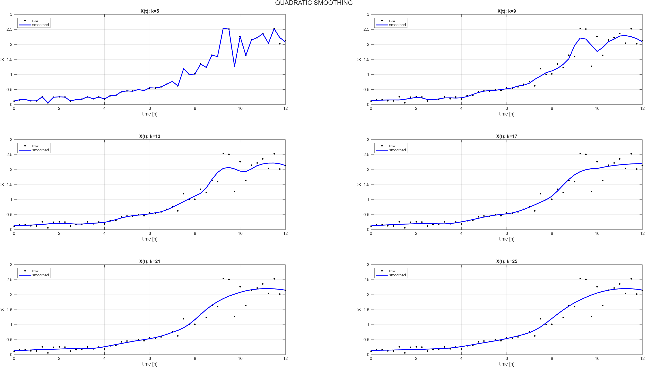

Figure 1: Quadratic Smoothing
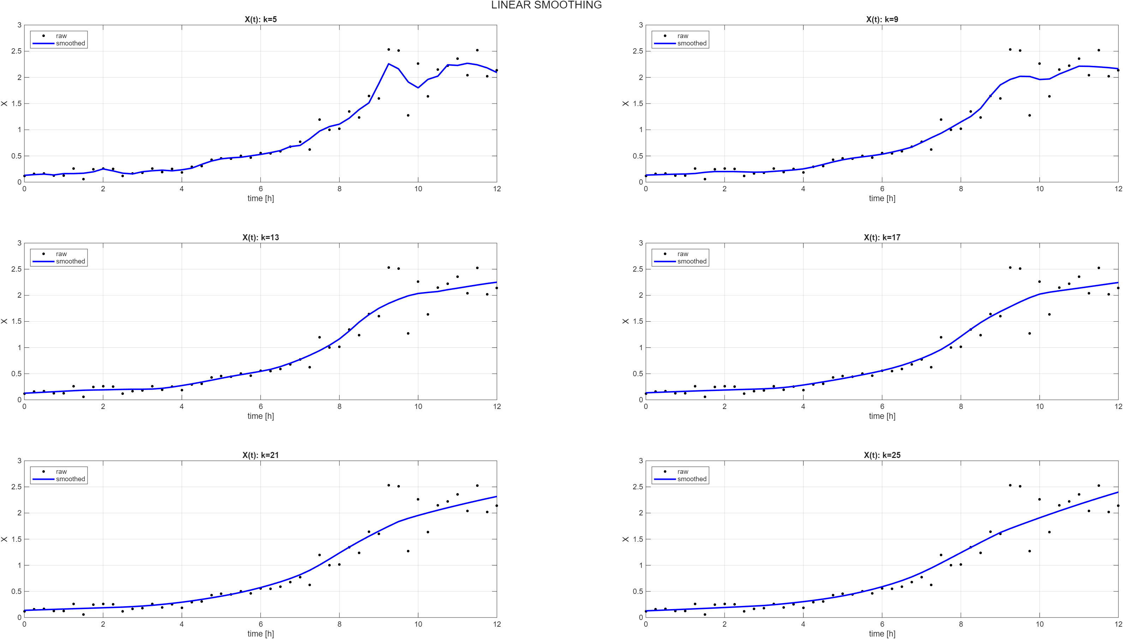

Figure 2: Linear Smoothing

3.1.2: Comparison
Let’s compare these 6*2 = 12 cases mathematically and visually. The metrics used are Root mean squared error and curvature. Root mean square error measures how far the smoothed values are from the real values. We want to avoid very high RMSE values since that would mean that our smoothed values are hypothetical and have no physical roots. We also consider mean of absolute curvature values. When the smoothed data is close to the ideal exponential growth and the noise is removed, the local curls are deleted, leading to a lower mean absolute curvature. Thus, our target should be to reduce the curvature without increasing the RMSE to a very high value.
We can fit an approximate curvature target by double differentiating the ideal growth curve:
$$\frac{d^{2}X}{dt^{2}}= μ^{2}X$$
We can either pick the $μ$ from the previous task or pick it regressively and select an average X from the logarithmic range. This gives the ideal curvature to be around 0.35*0.35*0.55 = 0.067 g/h². To allow a range, let’s allow 0.067 g/h² ± 20%. Note that the curvature of the raw data is 1.4761 g/h2.
K | Quadratic |  | Linear
K | RMSE | Circularity | RMSE | Circularity
5 | 0.0308 | 1.2476 | 0.1689 | 0.5638
9 | 0.1775 | 0.1928 | 0.5800 | 0.2428
13 | 0.1867 | 0.3221 | 0.2072 | 0.1080
17 | 0.2004 | 0.1524 | 0.2130 | 0.0782
21 | 0.2062 | 0.1272 | 0.2167 | 0.0597
25 | 0.2086 | 0.1076 | 0.2260 | 0.0443
Table 1: Comparison Metrics for Smoothing
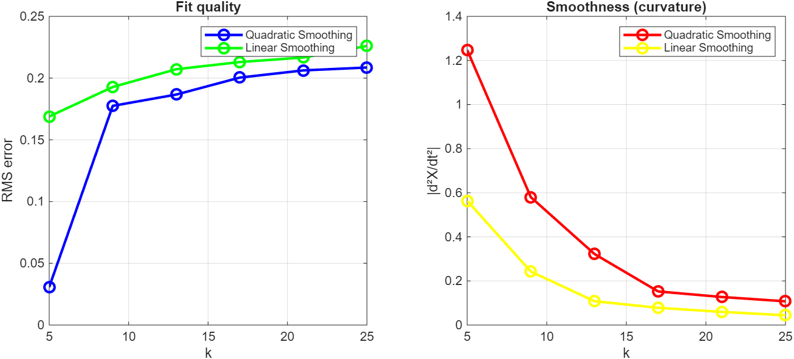
Figure 3: Comparison metrics

3.1.3: Observation and Analysis
Observe that for any given span, the quadratic smoothing has a lower RMSE than linear, i.e., it hugs the data closer. However, also observe that the circularity of each case is lower in linear than quadratic, meaning that the linear is closer to a trend-line. Next, observe the high span cases like k = 21 or k = 25 in quadratic for the timepoints after t = 9 hours. The data is clearly scattered at both the sides of the curve, showing high variability and noise while the quadratic function tries to fit a quadratic trend that doesn’t even exist or make sense. Moreover, observe that this time-period is better described by the linear smoothing. Finally, the linear curve hits the ideal curvature bracket at k = 17 with a curvature of 0.0782 and an RMSE of 0.213 while the quadratic is unable to achieve this even with a span of 25. Therefore, it can be recommended that linear is a better polynomial for smoothing when we want to observe the general trend like the average growth rate while a quadratic is better suited for cases where we want to see the perturbations in a standard curve since is able to capture the sub-local noise better.

3.2 Numerical Differentiation
In this section, we observe the effect of order on the numerical differentiation used for the raw and smoothed data. We use the predetermined optimal value of k = 17 for this analysis. The code has a function file which intakes the independent variable, dependent variable and the order. The code is made for the second and the third order. The boundary points are treated the same way for both the orders: forward difference at the starting point and backward difference at the end point. For the third order difference, at the second and penultimate time-points, 2nd order central difference is used. For comparison, we use the standard deviation metric.
Data | Order 2 | Order 3
Raw data | 0.502 | 0.649
Quadratic Smooth | 0.157 | 0.162
Linear Smooth | 0.090 | 0.091
Table 2: Comparison Metric for Differentiation
Observing these, one first intuition one might consider taking the second order difference due to a lower standard deviation. However, our requirement of the numerical differentiation is to compare the variability in calculation before and after smoothing. Therefore, it is important to select a difference tool that measures the noise more accurately. This makes the order 3 a better choice. Moreover, remember that order 3 is a more mathematically accurate method with a lower error order. Also, observe that for smoothed data, the difference in the two orders is lower. Finally, observe that the difference as well as the value of standard deviations is lower for linear smooth than quadratic smooth, proving that it is a better method of smoothing in this case.

3.3 Finding the Growth Rate
After establishing that order 3 is a better method for numerical differentiation, we use it to find the growth rate. The area of exponential growth is estimated using finding the area of almost constant growth rate. The said area is highlighted in this figure. 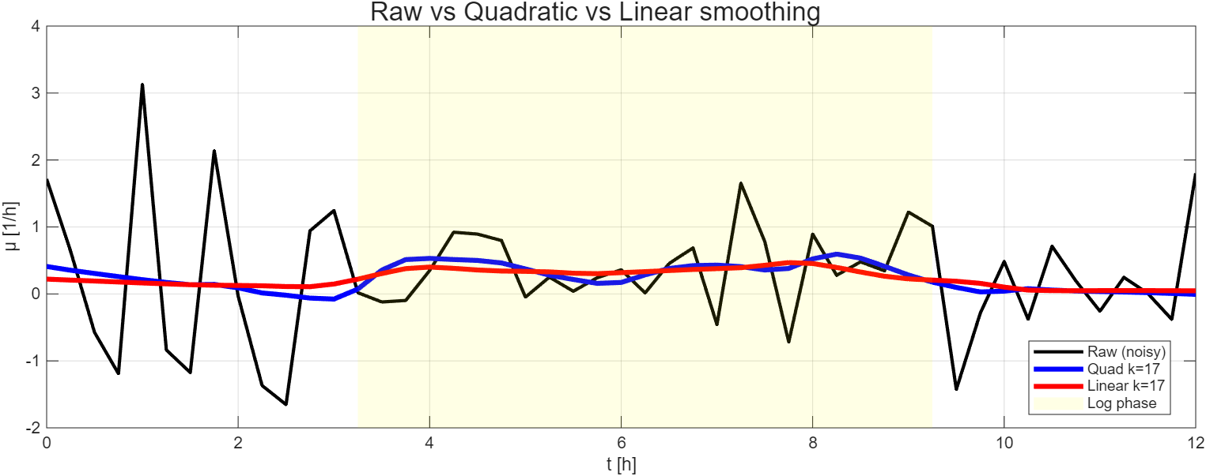
Figure 4: Growth Rate
Upon calculating the averages, we get:
Raw data: 0.4098 ± 0.5387
Quadrilateral Smoothing: 0.3732 ± 0.1386
Linear smoothing: 0.3424 ± 0.0671
The values are pretty close to each other and you can observe that the standard deviation for the growth rate is raw data > Quadrilateral smoothing > linear Smoothing.

